Council Reference: 49462E (D21/1370)

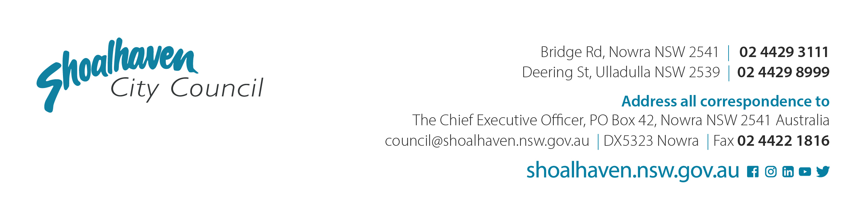

19/01/2021

NSW Department of Planning, Industry & Environment - Southern Region

By email only: wollongong@planning.nsw.gov.au

Attention: Sarah Lees, Director

Dear Ms Lees

**Request for New Gateway Determination**

**Planning Proposal PP005 for**

**Deferred Land, Warrah Road – Part of Crams Road Urban Release Area**

In accordance with Council’s resolution on 18 January 2021 (MIN21.6) I am writing to request a new Gateway determination under section 34 of the (Act) for the *Environmental Planning and Assessment Act, 1979* for the Warrah Road Planning Proposal (PP005) as updated – see attached.

**Background**

Correspondence from the Deputy Secretary, Mr Tim Hurst dated 15 December, 2020, advised that the Department had terminated Council’s five separate “legacy” planning proposals effective immediately. This included the Planning Proposal (PP) for Warrah Road, Bangalee (PP005) despite its relatively advanced status. The Southern Regional Office subsequently advised that new Council resolutions would be required before any request for a new Gateway would be considered.

DPIE’s correspondence and actions in relation to the five “legacy” Planning Proposals were considered by Council on 18 January 2021 and it was resolved (MIN21.6):

*That Council*

1. *Acknowledge that the Gateway determinations for the Planning Proposals (PPs) in question were terminated by the NSW Department of Planning, Industry & Environment (DPIE) on 15 December 2020.*
2. *Continue to progress each PP as follows:*
   1. ***Warrah Road, Bangalee (PP005): seek a new Gateway determination immediately and if the outcome is favourable, place the PP and supporting documentation on public exhibition.***
   2. *[…]*
   3. *[…]*
   4. *[…]*
   5. *[…]*
3. *[…]*
4. *Receive a future report on revising/updating Council’s Planning Proposal Guidelines once DPIE has updated it is relevant guidelines and the revised Planning Proposal process is clearer.*

**Strategic context**

PP005 applies to deferred land within the Crams Road Investigation Area identified in the Nowra-Bomaderry Structure Plan and the Shoalhaven Growth Management Strategy. In turn, the land is part of one the ‘regionally significant release areas’ identified in the Illawarra-Shoalhaven Regional Plan 2036.

The PP seeks to resolve the planning status of land within the Crams Road Investigation Area that was deferred in Shoalhaven Local Environmental Plan (LEP) 2014 that is currently zoned Rural 1(d) (General Rural) under Shoalhaven LEP 1985. The land is proposed to be rezoned to a mix of E2 - Environmental Conservation, RU2 - Rural Landscape, R5 – Large Lot Residential, and R2 - Low Density Residential.

The proposed residential area will be mapped as an ‘Urban Release Area’ to which Part 6 of the LEP will apply. Hence, a site-specific Development Control Plan chapter would need to be prepared, and State and public utility infrastructure will have to be arranged before the land can ultimately be subdivided/developed.

**Updated Planning Proposal PP005 – Warrah Road, Bangalee**

The PP seeks to amend Shoalhaven LEP 2014 to rezone the land to a mix of E2 - Environmental Conservation, RU2 - Rural Landscape, R5 – Large Lot Residential and R2 - Low Density Residential. The PP details all the intended amendments to the LEP, provides links to the supporting technical studies, includes all agency responses received so far and Council comments as appropriate, and contains links to all relevant reports presented to Council and the resulting Council resolutions up to and including 18 January 2021.

We believe that the updated PP005 satisfies the pre-exhibition requirements of the original Gateway determination (as amended prior to its termination by DPIE).

Technical studies including biodiversity conservation, bushfire and Aboriginal archaeological assessments have all been received, and agency comments requested. Importantly, on 3 November 2020, the Biodiversity Conservation Division of DPIE, approved the proponent’s Biodiversity Certification Assessment Report (BCAR) for exhibition concurrently with the PP in accordance with s8.6(6) of the *Biodiversity Conservation Act 2016*. This concurrent exhibition depends upon a new Gateway determination being issued.

**Agency consultation**

Council is awaiting detailed comments from key government agencies including the NSW Rural Fire Service (RFS) and the Natural Resources Access Regulator (NRAR). RFS comments are needed to determine compliance with s9.1 Ministerial Direction 4.4.

During discussions on Tuesday, 22 December 2020, DPIE officers confirmed that a request for a new Gateway would receive due consideration and that consultation with the RFS and NRAR could continue during the exhibition period of the PP, and beyond, if necessary.

Your urgent assistance in getting timely responses from RFS and NRAR is sought given they are critical to the progression and resolution of this PP.

**Inconsistency in original Gateway determination - future western by-pass corridor**

It should be noted that the revised PP is inconsistent with Condition 1 of the original Gateway determination:

*The planning proposal is to be revised to remove the proposed residential zoning over the lands in sub-remediation areas A and B of the section 38 Remedial Direction under the Native Vegetation Act 1993. An appropriate environmental zone is to be applied to these areas.*

Figure 18 in the updated PP also shows that there is a considerable overlap between the remediation area and future western bypass corridor which is proposed to be zoned RU2 Rural Landscape. An environmental zone would not be appropriate for this corridor, which is identified for the future alignment of the highway. Note: the future western bypass corridor was previously identified for road infrastructure in the NBSP (endorsed by DP&E 2008) and the draft Shoalhaven Local Environmental Plan 2014.

It is our understanding that the Department remains supportive of the proposed RU2 zoning for the future western bypass and that the above issue in the original Gateway determination was unintended. Your earliest advice would be appreciated if this is not the Department’s view.

**Time frame and next steps**

The timeframe requested for finalisation is 9 months. A work program is reproduced below from the updated PP.

|  |  |
| --- | --- |
| **Task** | **Anticipated Timeframe** |
| New Gateway request | January 2021 |
| Completion of studies required by original Gateway Determination | Completed |
| Public exhibition (minimum 28 days) | March 2021 |
| Post exhibition consideration of PP | June 2021 |
| Finalisation and notification of Plan | August 2021 |

Subject to receiving a favourable Gateway determination, we will formally exhibit the PP and BCAR, while consulting further with the relevant NSW Government Agencies, including the RFS and NRAR, and the Biodiversity Conservation Division (DPIE). Any feedback from these agencies will be considered along with community feedback before seeking to finalise the PP.

To the extent that it will help expedite the plan-making process, Council also seeks delegated plan-making authority.

We look forward to your continued assistance in progressing the Warrah Road PP to a timely resolution. If you would like to discuss the proposal or any of the matters highlighted in this letter, please contact Eric Hollinger on (02) 4429 3320 or email: [eric.hollinger@shoalhaven.nsw.gov.au](mailto:eric.hollinger@shoalhaven.nsw.gov.au). Please quote Council’s reference 55387E (D21/1370).

Yours faithfully

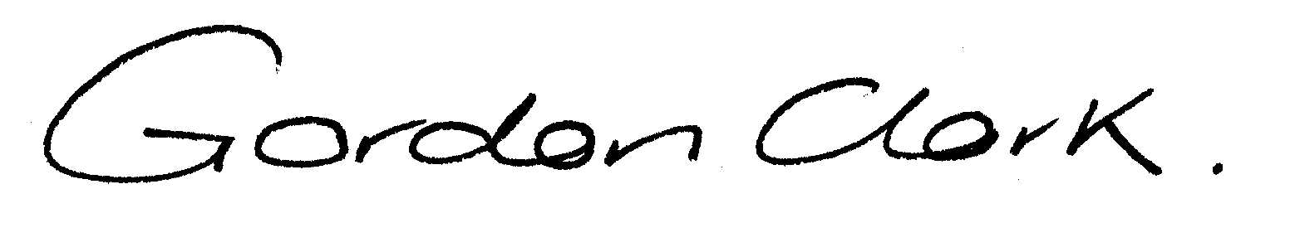

**Gordon Clark**

**Strategic Planning Manager**

Enc: Planning Proposal Warrah Road PP005